

ATTENTION JOB SEEKERS!

Come to Job Club!
Don’t miss this opportunity to attend a CalWORKs Employment Workshop for free.
We will give you the skills to excel in the modern day workforce.

WHAT IS JOB CLUB?

Job Club is an interactive comprehensive training available for CalWORKs Welfare to Work (WTW) participants at various locations throughout the county.


WHAT CAN I EXPECT IN JOB CLUB?
- Résumé Building
- Job Searching Techniques
- One-on-One Coaching

- Confidence Building
- Supportive Services
- Interview Prep
- Job Leads
- Life Skills
- Goal Setting
- Transportation Payments – To help participants get to their activity
- Child Care Subsidies –To help make sure participants’ children are cared for while in their activity
- Interview Clothes – To assist participants with appropriate, professional clothing

AS A JOB CLUB PARTICIPANT, YOU ALSO WILL HAVE ACCESS TO THE FOLLOWING SERVICES

- JOB DEVELOPERS- Job Club participants can be placed in paid, permanent positions through subsidized employment and can also receive unsubsidized job leads.

- VOCATIONAL ASSESSMENT COUNSELORS-Job Club participants have the opportunity to develop vocational and self- employment plans, participate in career exploration, be assessed for Learning Disabilities, and/or have their degree evaluated.
- COMMUNITY WORK EXPERIENCE (CWEX)-Job Club participants are offered non-paid work experience with public and/or private businesses to help them learn valuable on-the-job skills and move into paid employment.


- JOB TALKS-Job Talks are offered for all Job Club participants to connect to employment in the community.

TESTIMONIALS FROM FORMER JOB CLUB PARTICIPANTS

“Without Job Club, I don’t believe I would have gotten a job as quickly as I did.” - James C.

“It put me in the right mindset to get myself a job. The program gave me a new prospective on my long-term career goals.” -Shanice W.

“I received additional knowledge and skills through the Job Club experience. I am greatly appreciative of the program and the guidance I received.” -Walker M.

“I was struggling with every skill and Job Club helped. From my résumé to the interview, and everything in between.” -Danasha L.


“I now have the confidence and skills I need to go on an interview.” -Tiffany M.

ENROLL IN JOB CLUB TODAY!
Contact your Welfare-to-work worker to request enrollment.
If you don’t know who your worker is,
you can call 1-800-560-0976.

Visit our Employment Services website at:
https://ha.saccounty.gov/EmploymentServices

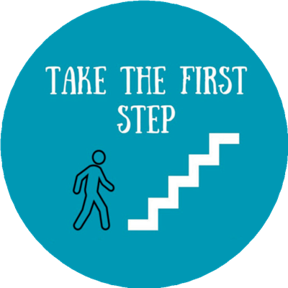

Sacramento County Board of Supervisors
Phil Serna- District 1
Patrick Kennedy- District 2
Rich Desmond- District 3
Rosario Rodriguez- District 4
Patrick Hume- District 5
David Villanueva- County Executive

 DEPARTMENT OF HUMAN ASSISTANCE
Employment Services
Improving Lives Daily

