
VOCATIONAL ASSESSMENT & CAREER COUNSELING

Building Career Paths

Any of these apply to you?
- Are you confused about your career goal?
- Are you interested in education and job training?
- Are you self-employed?
- Are you curious about your vocational interests and abilities?
- Do you have limited work history?
- Do you have a disability or learning difficulty?
- Do you currently have challenges getting in the way of your
- employment plans?

If yes, and you are eligible, you can ask for a referral to one of our Vocational Assessment Counselors.

Who are we?
Vocational Assessment Counselors are trained professionals who provide career counseling and specialized assessments to assist you with your career goals

What do we offer?
We offer individualized counseling and guidance. Together, we will help develop an achievable step-by-step plan that will meet your Welfare-to-Work requirements and career goals. We look at your employment and training needs and utilize specialized assessment tools, as needed, to measure career interests, aptitudes, values, personality, academic and vocational skills.

Career Planning Service
- Career Exploration
- Education, Employment and
- Vocational Counseling Training

Specialized Assessment Tools
- Academic Skills
- Aptitudes, Abilities
- Interests
- Learning Disabilities
- Self-Employment
- Vocational Skills

Vocational Assessment’s Mission
Provide career counseling services through personalized vocational assessment and evaluation Promote self-awareness by identifying individual Strengths, Interests, Aptitudes, Potential.

For Information and referral, contact 916-875-3330

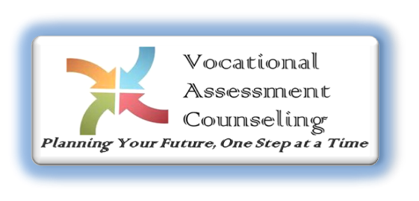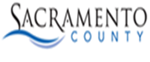
Sacramento County
Board Of Supervisors
Phil Serna District 1
Patrick Kennedy District 2
Rich Desmond District 3
Rosario Rodriguez District 4
Patrick Hume District 5
David Villanueva
County Executive

